Data Cleaning and Formatting Project

Made By
Afifah Khatoon

Objective
The main objective of this project is to clean and organize raw data into a proper and structured format for accurate analysis and reporting. This project helps improve data quality by removing errors, duplicates, missing values, and formatting issues.

Project Description
This project focuses on cleaning and organizing raw data to make it accurate, consistent, and ready for analysis. Different data cleaning techniques were applied to remove errors and improve data quality.

Tasks Performed
- Removed duplicate records
- Handled missing values
- Corrected formatting issues
- Standardized text and date formats
- Applied filters and sorting
- Organized data into a structured format

Tools Used
- Microsoft Excel
- Excel Functions & Formatting Tools
- Basic Excel Functions
Raw Dataset :-
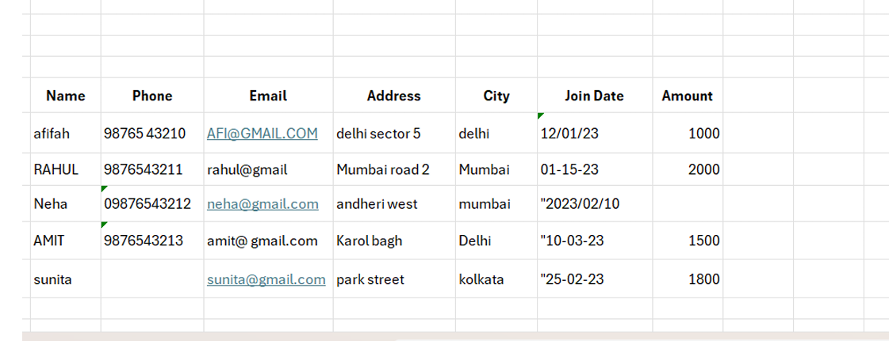

Data Cleaning Process:-

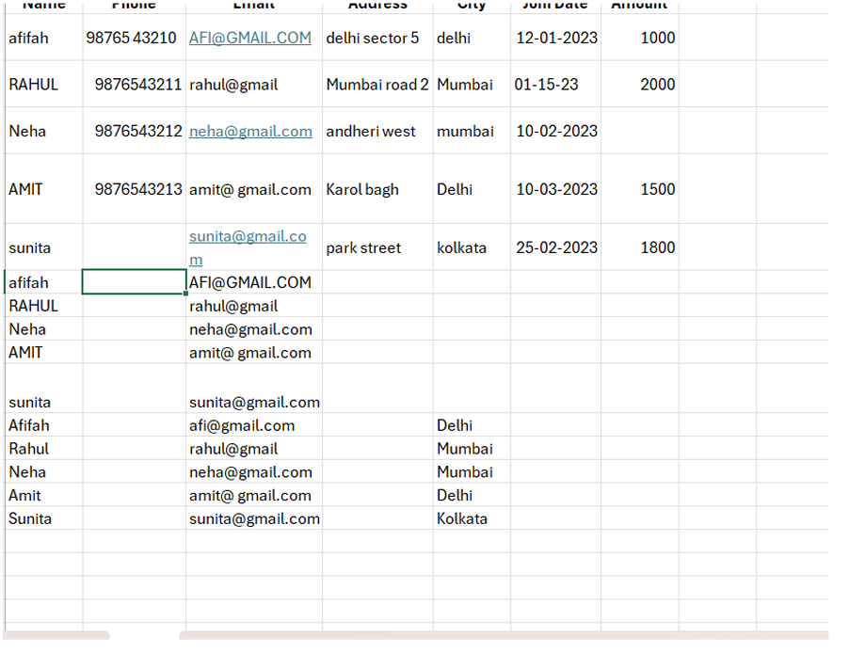

Cleaned Dataset:-
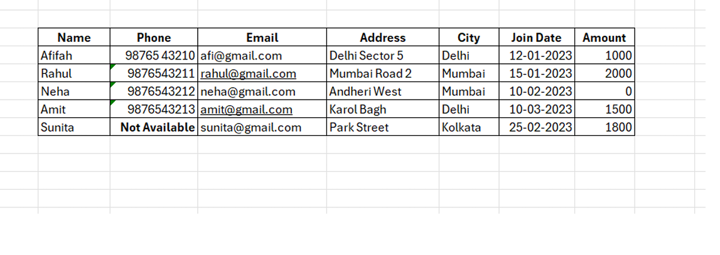
Conclusion:-
This project successfully converted unorganized raw data into a clean and structured dataset. Proper data cleaning and formatting improve data accuracy, consistency, and efficiency for future analysis and decision-making.

Thank You,

